Q. 1) Find all the unique 'Wind Speed' values in the data.

The unique “Wind Speed” values in the data are :

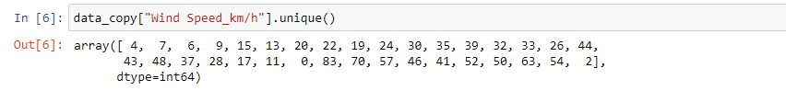

**There are 35 unique values in “wind Speed”.**

Q. 2) Find the number of times when the 'Weather is exactly Clear'

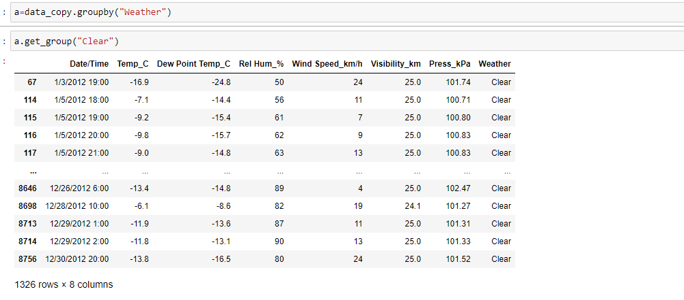

**Weather is Exactly clear for 1326 times.**

Q. 3) Find the number of times when the 'Wind Speed was exactly 4 km/h'.

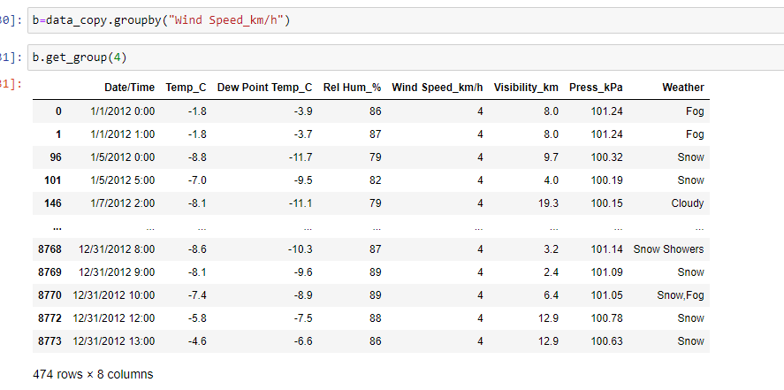

**There are 474 data points where the “Wind Speed was Exactly clear 4km/h”**

Q. 4) Find out all the Null Values in the data.

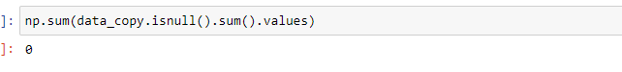

**The count of null values in the dataset is 0. Hence no null value exists**

Q. 5) Rename the column name 'Weather' of the dataframe to 'Weather Condition'.

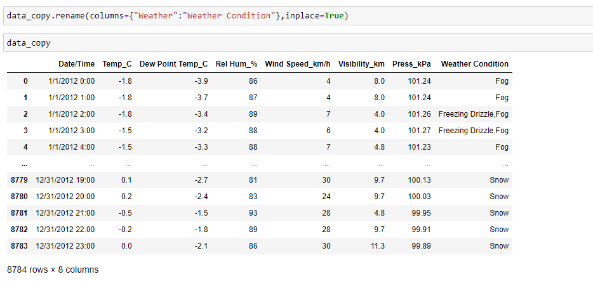

**column name 'Weather' is renamed into 'Weather Condition'**

Q. 6) What is the mean 'Visibility' ?

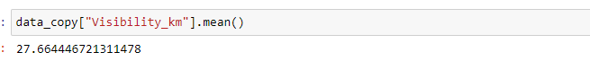

**The mean of “Visibility” is 27.664km**

Q. 7) What is the Standard Deviation of 'Pressure' in this data?

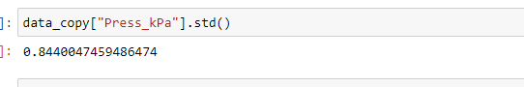

**The Standard deviation of “Pressure is 0.8440**

Q. 8) What is the Variance of 'Relative Humidity' in this data ?

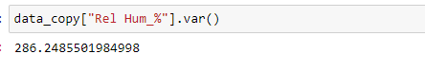

**The Variance of “Relative Humidity” is 286.2485**

Q. 9) Find all instances when 'Snow' was recorded.

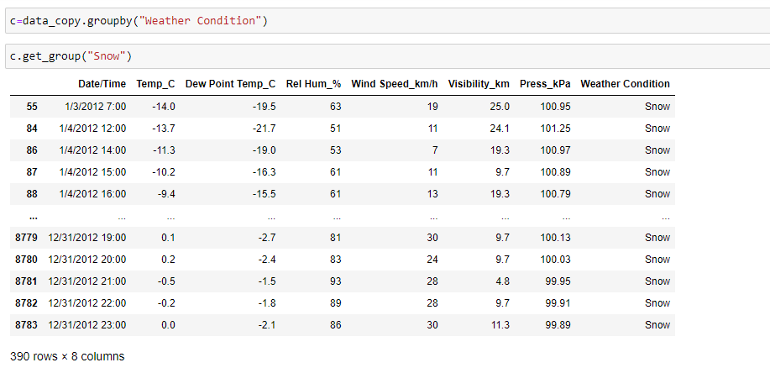

**There are 390 data points where the weather condition “Snow“ was recorded.**

Q. 10) Find all instances when 'Wind Speed is above 24' and 'Visibility is 25'.

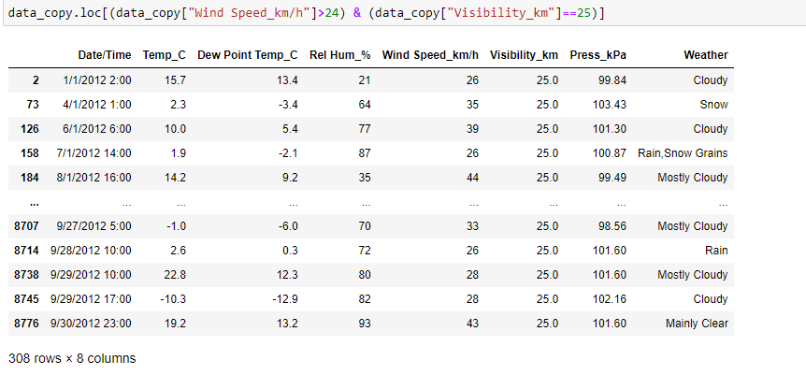

**There are 308 data points that shows the “wind speed” above 24 and “Visibility” is 25.**

Q. 11) What is the Mean value of each column against each 'Weather Condition ?

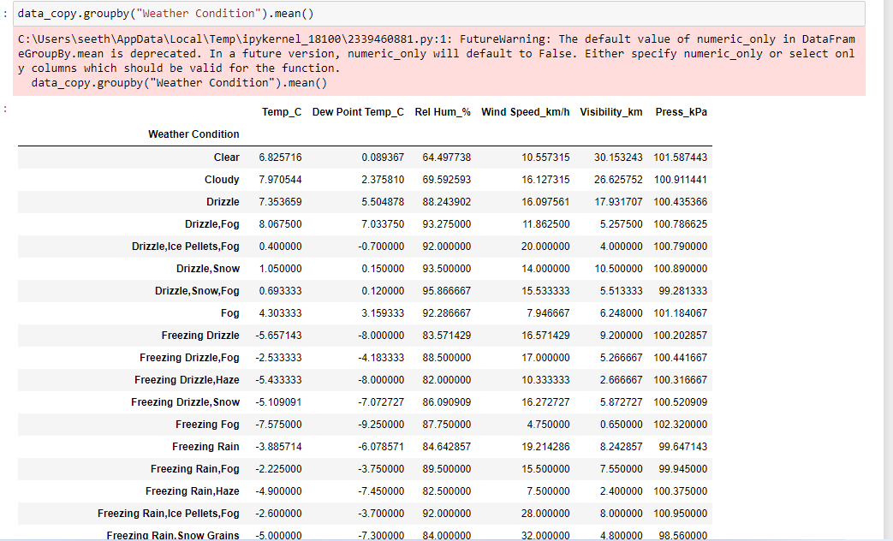

**Here the above code shows the mean value of each column against Weather Condition**.

Q. 12) What is the Minimum & Maximum value of each column against each 'Weather Condition ?

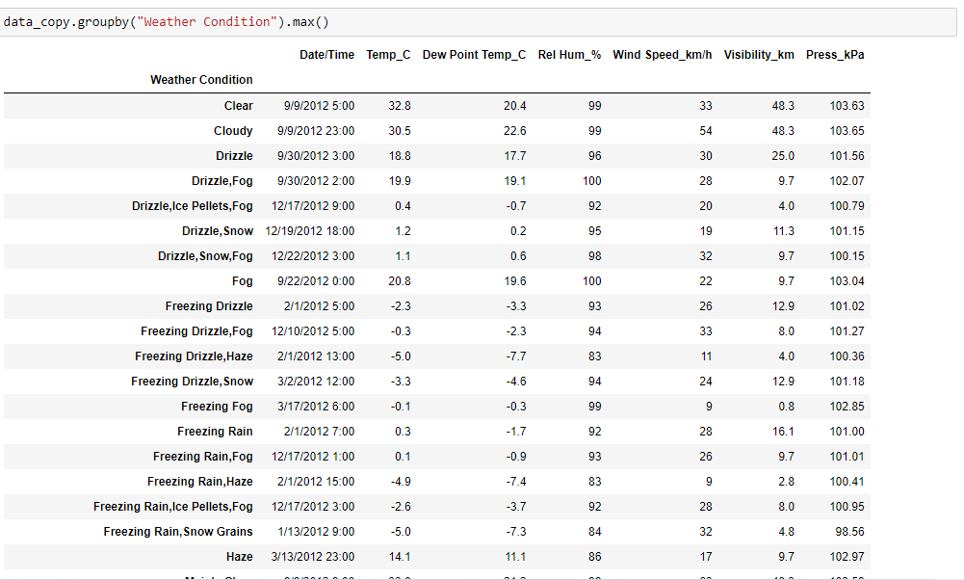



**Here we can see the Minimum & Maximum value of each column against each 'Weather Condition.**

Q. 13) Show all the Records where Weather Condition is Fog.

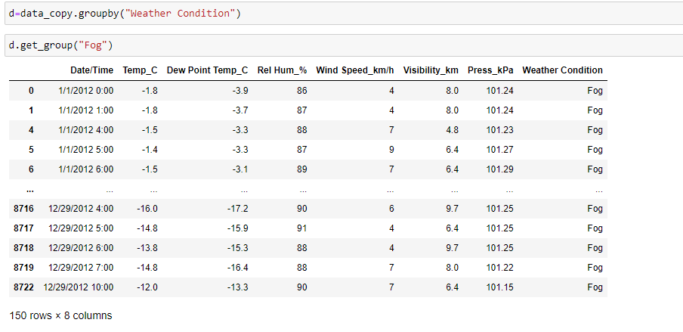

**There are 150 data points where the Weather condition is “Fog**”.

Q. 14) Find all instances when 'Weather is Clear' or 'Visibility is above 40'.

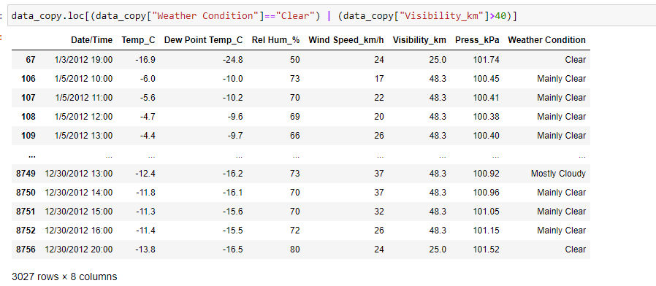

**There are 3027 instances when“ Weather is Clear “or “Visibility” is above 40.**

Q. 15) Find all instances when:

A. 'Weather is Clear' and 'Relative Humidity is greater than 50' or

B. 'Visibility is above 40'

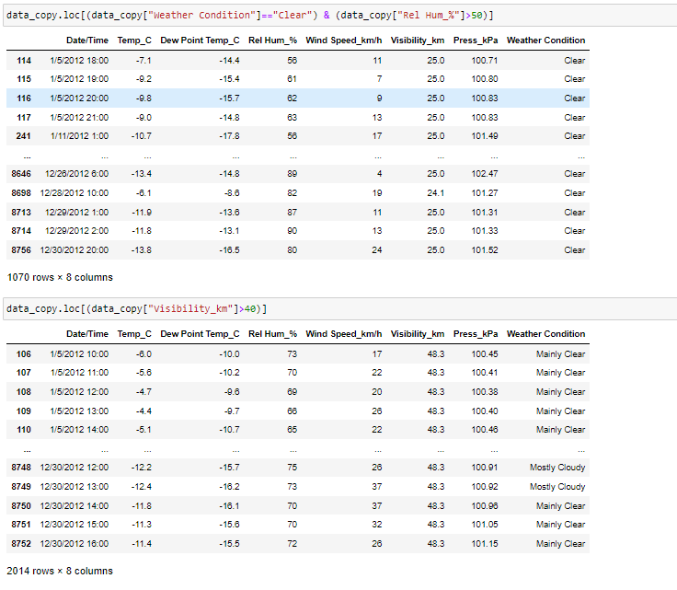

**There are 1070 data points where the Weather is Clear and Relative Humidity is above 50**

**There are 2014 data points where the visibility is greater than 40**